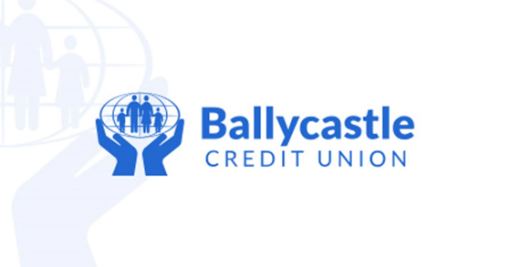
1 The Diamond, Ballycastle, County Antrim, BT54 6AS
Telephone: 028 207 62188 Web: www.ballycastlecu.com
Minor Applicant Information
Name: Click or tap here to enter text.

Date of birth: (DD MM YYYY) Click or tap here to enter text.
Current address: Click or tap here to enter text.
Click or tap here to enter text.
Click or tap here to enter text.

City/Town:Click or tap here to enter text. | County:Click or tap here to enter text. |  |  | Postcode:Click or tap here to enter text.
School: |  |  | Class:
Parent / Guardian Information
Name: Click or tap here to enter text.
Date of birth: (DD MM YYYY) Click or tap here to enter text.

Telephone: Click or tap here to enter text. |  | Email: Click or tap here to enter text.
Member of Ballycastle Credit Union? : (Y / N) Click or tap here to enter text.

For and on behalf of the first-name person I, Click or tap here to enter text. the parent/guardian of the said
Click or tap here to enter text. hereby apply to open an account in the name of the said Click or tap here to enter text. and I agree to abide by the rules of Ballycastle Credit Union Limited regarding such account and declare that the information given by me on this form is true and correct to the best of my knowledge and belief.

Signature of Parent/Guardian: Click or tap here to enter text.

Date: (DD MM YYYY) Click or tap here to enter text.
Complete if applicant is over 7.
I (Minor) Click or tap here to enter text. aged Click or tap here to enter text. years hereby confirm the above application and I wish to open an account in Ballycastle Credit Union Limited.
I authorise you:
- to open the account in my name; and
- to process the information I have provided you with for the purposes of maintaining my account with us.
Signature: Click or tap here to enter text.
Date: DD MM YYYY Click or tap here to enter text.

